Estimation of Business Expenses

**1. INTRODUCTION**:

* 1. **OVERVIEW:**

An overview of the estimation of business expenses can be summarized as follows:

**What is it?** Estimation of business expenses is the process of forecasting and planning for the costs and expenditures that a business will incur to operate and achieve its objectives. It involves categorizing expenses, creating budgets, and regularly reviewing and adjusting financial projections.

**Importance:** Accurate expense estimation is crucial for effective financial management. It allows businesses to allocate resources efficiently, make informed decisions, and avoid financial instability. It also aids in setting financial goals and monitoring the financial health of the organization.

**Key Steps:**

1. **Identify Expense Categories:** Categorize expenses into various groups, such as operating expenses, cost of goods sold, personnel expenses, marketing, and more.
2. **Historical Data Analysis:** Analyze past financial data to understand expense patterns and variations.
3. **Market Research:** Study industry benchmarks and market conditions to set realistic expense expectations.
4. **Expense Budgeting:** Create budgets for each expense category, considering historical data and future projections.
5. **Variance Analysis:** Regularly compare actual expenses to budgeted expenses and investigate significant differences.
6. **Contingency Planning:** Set aside a contingency fund for unexpected expenses and emergencies.
7. **Regular Review and Updates:** Periodically review and update expense estimates to reflect changing circumstances.
8. **Expense Management Tools:** Consider using software and tools to streamline expense tracking and management.
9. **Consult Financial Professionals:** Seek advice from financial experts when needed to improve expense estimation.
10. **Adapt and Learn:** Continuously improve your expense estimation process based on experience and feedback.
    1. **PURPOSE**:

The purpose of estimating business expenses serves several critical functions for organizations:

1. **Financial Planning:** Estimating expenses is essential for creating a comprehensive financial plan or budget. A well-structured budget helps a business allocate resources efficiently and plan for future expenditures, ensuring that it has the funds necessary to cover its operating costs and achieve its financial goals.
2. **Resource Allocation:** By understanding and estimating expenses, a business can allocate its resources effectively. It can determine how much to allocate for different expense categories, ensuring that it can meet its operational needs and invest in growth and development.
3. **Decision-Making:** Expense estimation is crucial for informed decision-making. When businesses have a clear understanding of their anticipated costs, they can make strategic decisions about investments, pricing, expansion, and cost-cutting measures. This informed decision-making can lead to improved profitability.
4. **Performance Evaluation:** By comparing actual expenses to budgeted expenses, businesses can assess their financial performance. This evaluation allows them to identify areas where they may be overspending or where they have room to invest more. It's a fundamental tool for measuring financial health.
5. **Risk Mitigation:** Contingency planning, which is an integral part of the expense estimation process, helps businesses prepare for unexpected expenses or financial emergencies. Having a contingency fund in place can mitigate financial risks and maintain stability in times of crisis.
6. **Setting Financial Goals:** Expense estimation is necessary for setting financial goals and targets. Whether it's achieving a certain level of profitability or managing expenses to increase cash flow, clear estimations are the basis for goal setting.
7. **Tax Planning:** Understanding and estimating expenses is crucial for tax planning. It helps businesses calculate their tax liabilities accurately, take advantage of tax deductions and credits, and optimize their tax strategy.
8. **Funding and Investment:** When seeking external funding or investments, businesses need to provide detailed expense estimates to potential investors or lenders. Reliable estimations demonstrate that the business has a solid grasp of its financial needs and a plan to manage them.
9. **Continuous Improvement:** Over time, expense estimation allows businesses to learn from their financial experiences. By analyzing variances between estimated and actual expenses, they can identify areas for improvement and fine-tune their budgeting process.
10. **Legal and Regulatory Compliance:** Many businesses are required to maintain accurate financial records and report expenses for compliance with legal and regulatory requirements. Estimating expenses and keeping detailed records is crucial for meeting these obligations.

**2. PROBLEM DEFINITION AND DESIGN THINKING:**

2.1 **EMPATHY MAP:**

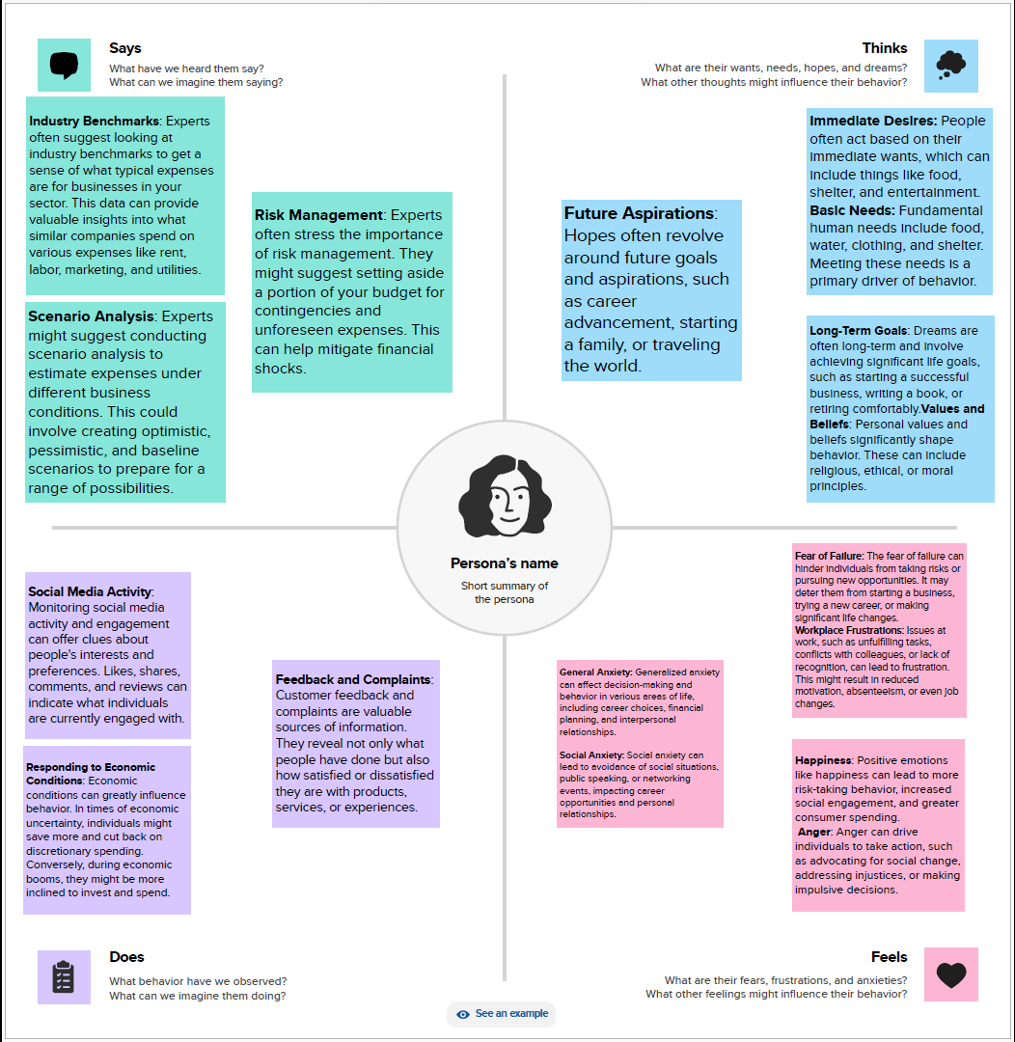

2.2 **IDEATION AND BRAINSTORMING MAP:**

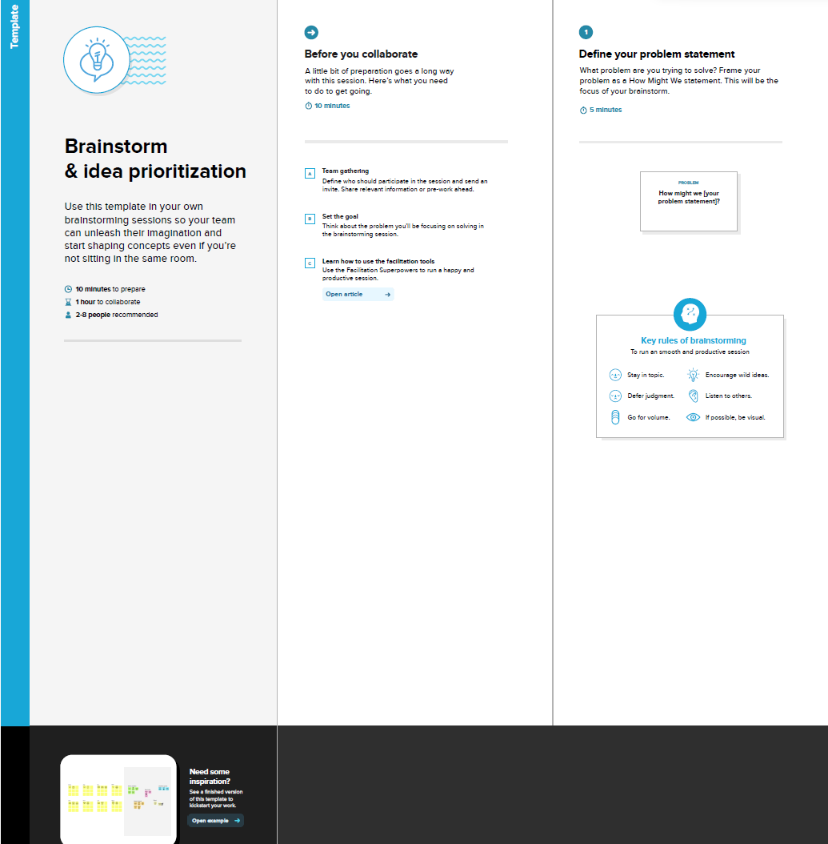

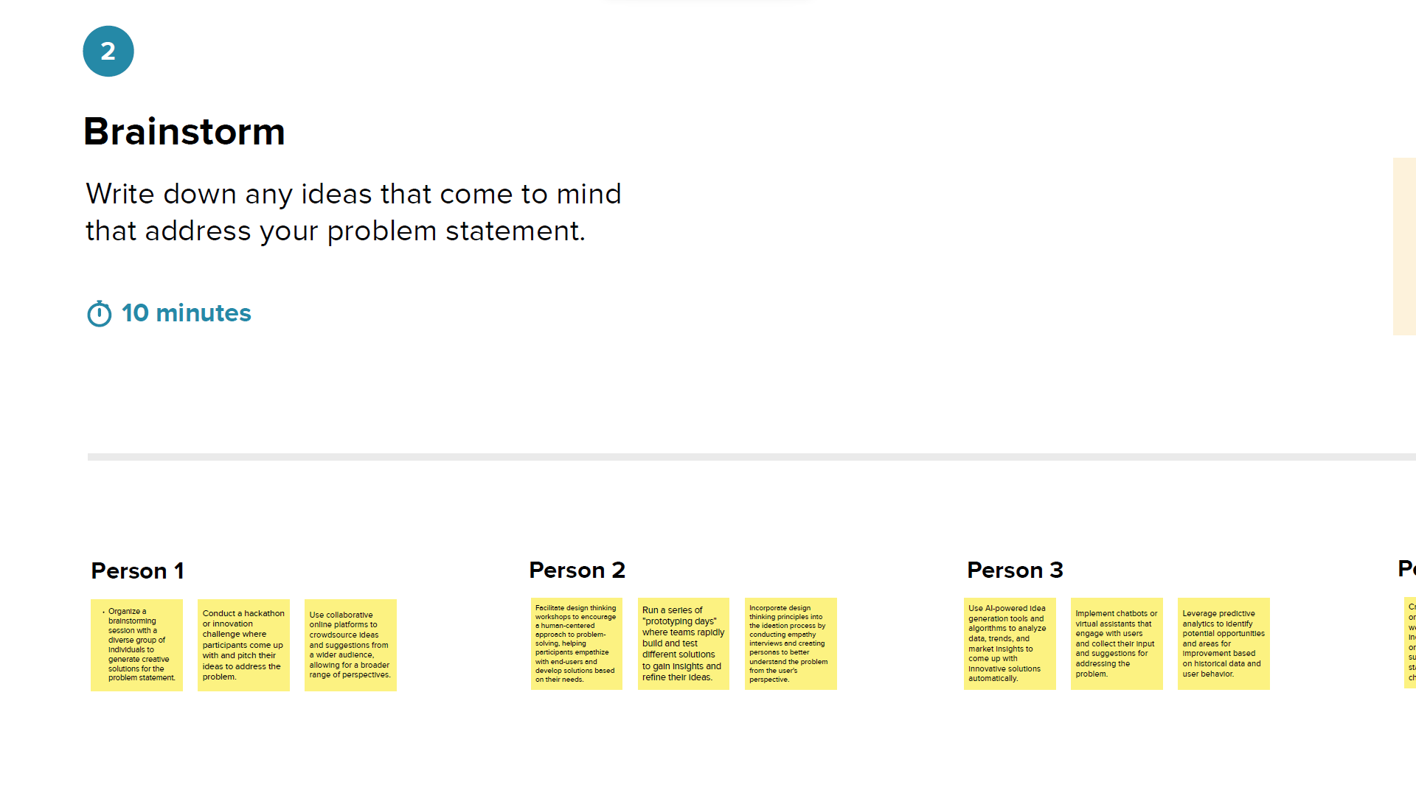

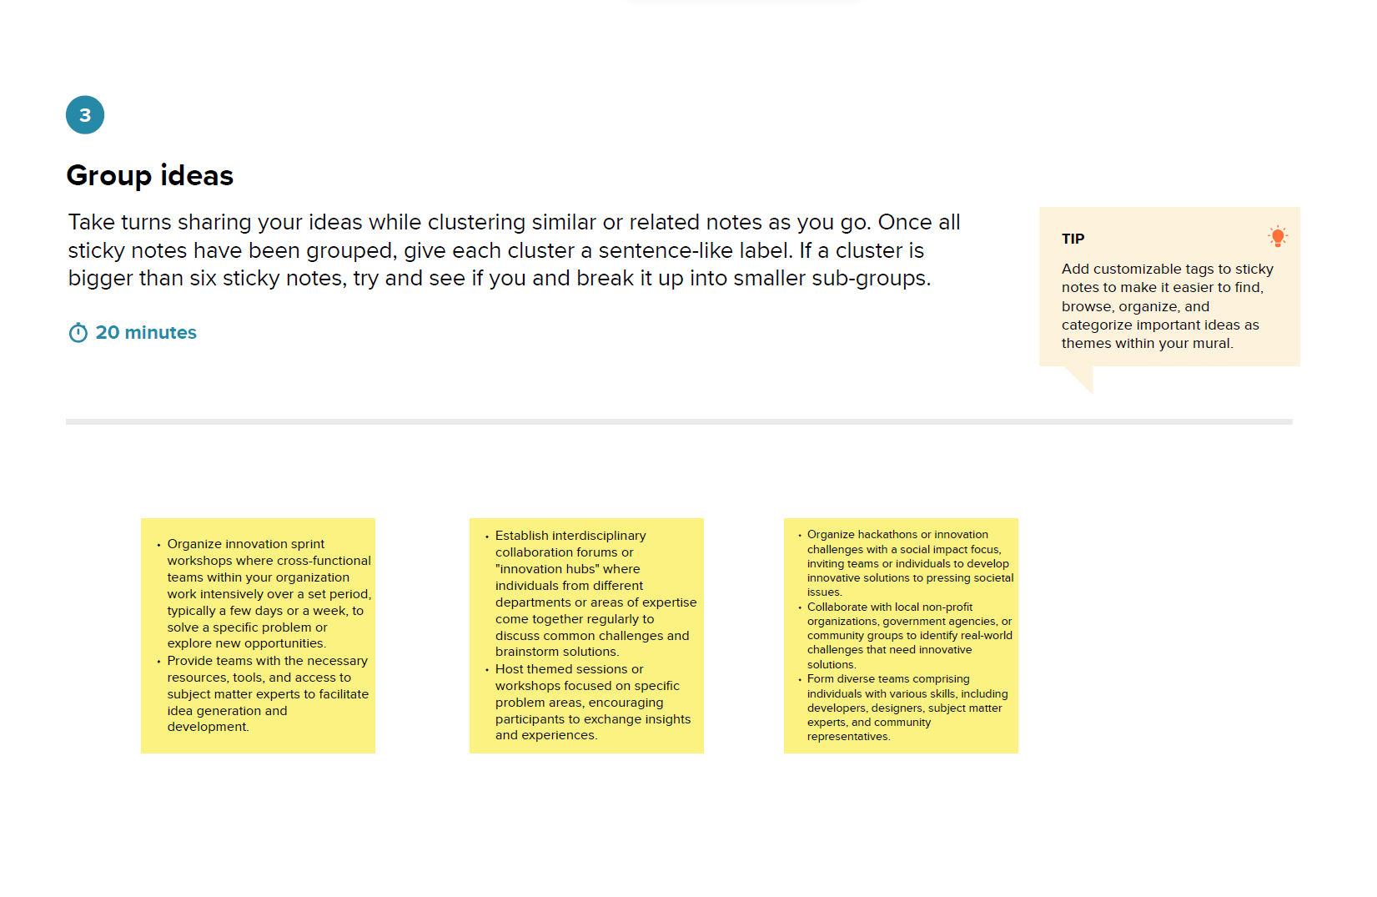

**3. RESULT:**

**DASHBOARD 1**

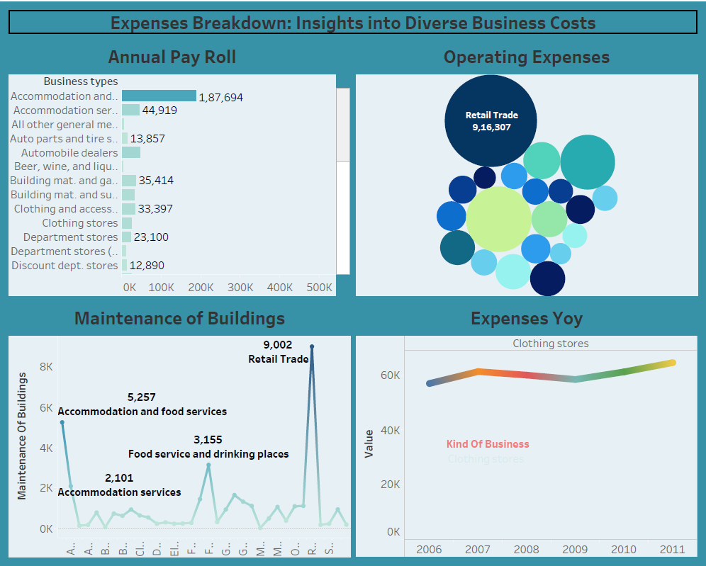

**DASHBOARD 2**

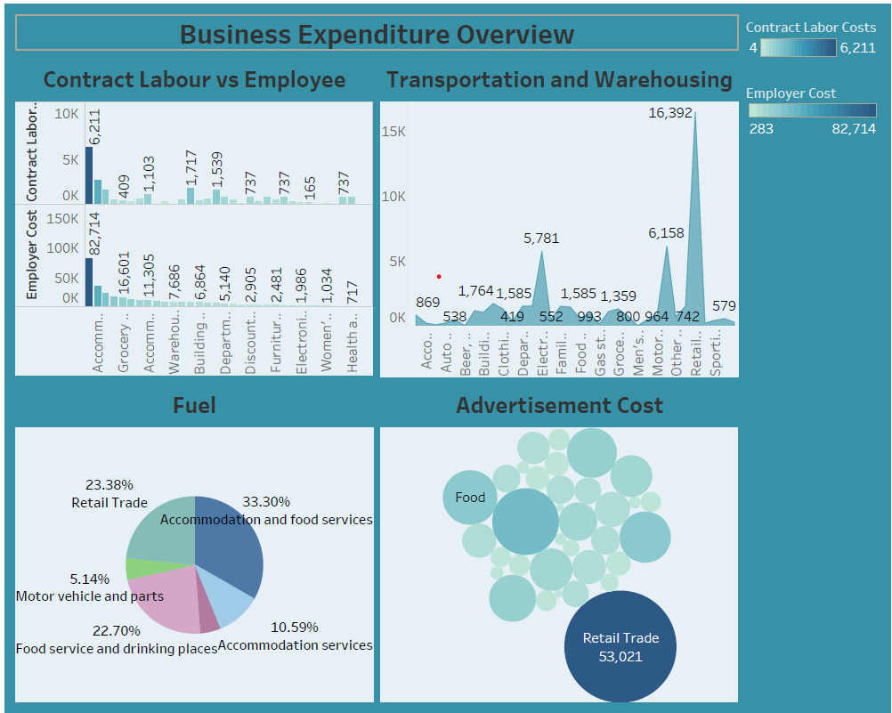

**DASHBOARD 3**

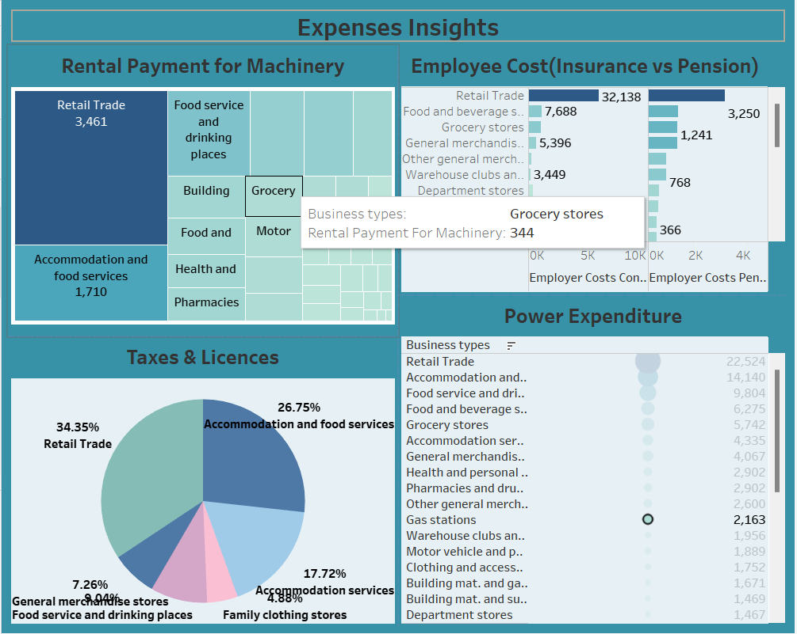

**STORY 1**

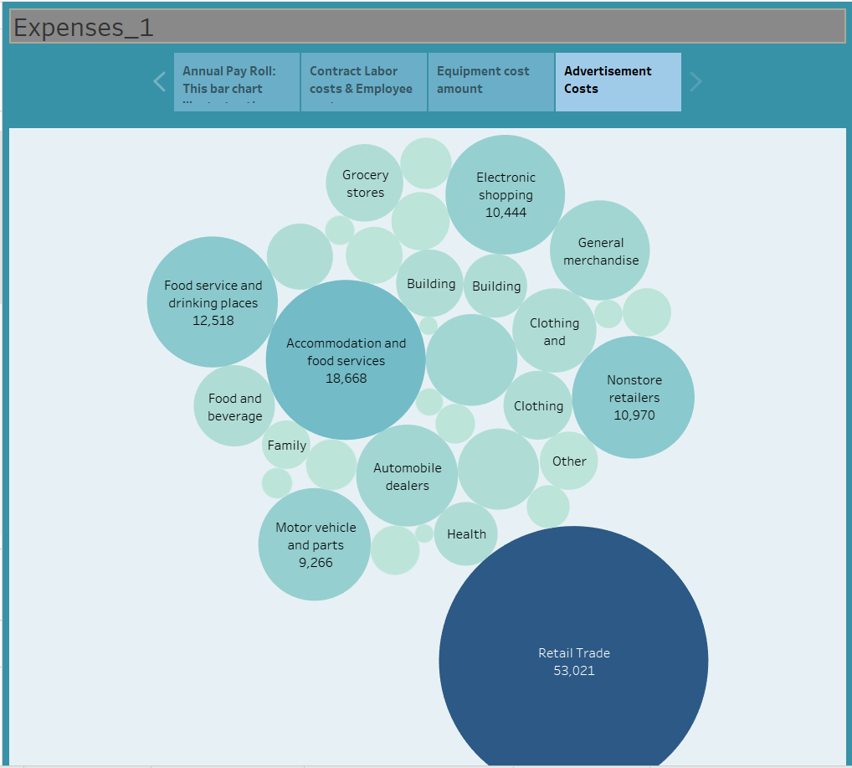

**STORY 2**

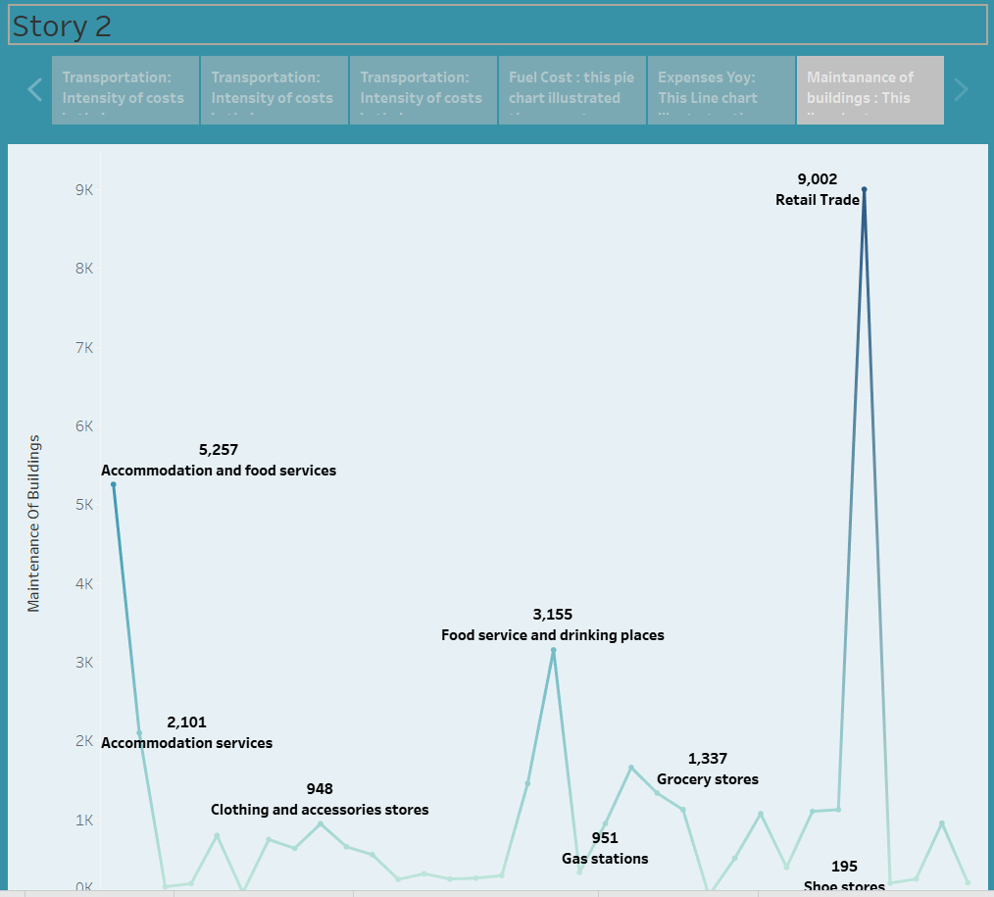

**4. ADVANTAGES AND DISADVANTAGES:**

**Advantages of Estimating Business Expenses:**

1. Financial Planning
2. Resource Allocation
3. Informed Decision-Making
4. Performance Evaluation
5. Risk Mitigation
6. Goal Setting
7. Tax Planning
8. Funding and Investment
9. Continuous Improvement
10. Legal and Regulatory Compliance

**Disadvantages of Estimating Business Expenses:**

1. Inaccuracy
2. Time-Consuming
3. Assumption-Based
4. Over-Optimism
5. Underestimation
6. Resistance to Change
7. Data Quality Issues
8. Rigid Budgets
9. Neglect of Contingencies
10. Potential for Micromanagement

**5. APPLICATIONS:**

**Applications of Estimating Business Expenses:**

1. Budgeting
2. Cost Control
3. Financial Forecasting
4. Investment Analysis
5. Pricing Strategies
6. Financial Reporting
7. Tax Planning
8. Risk Management
9. Resource Allocation
10. Performance Evaluation

**6. CONCLUSION:**

Estimating business expenses is an ongoing and essential aspect of financial planning for organizations. It helps ensure financial stability, sound decision-making, and the achievement of financial goals. By following these steps and staying vigilant in monitoring and managing expenses, businesses can maintain financial health and adapt to changing economic conditions.

**7. FUTURE SCOPE:**

The future scope of estimating business expenses is expected to be increasingly data-driven and technology-dependent. Automation and artificial intelligence will play a pivotal role in making expense estimation more accurate and efficient. Moreover, businesses will likely focus on sustainability and environmental considerations, leading to the incorporation of green expense estimation practices. As the global economy evolves, the scope will also expand to accommodate changing market dynamics, international trade, and regulatory compliance, making it essential for businesses to adapt and innovate in their expense estimation strategies.